
SC1007 Data Structures and Algorithms
Tutorial 6: Trie

Step 1: Find the correct start node
Step 2: Choose DFS (simple) or BFS (slightly more complicated due to the use of queue if you need depth, then BFS is the only choice, otherwise just choose DFS)
Step 3: Decide what to do or when to stop

 | Q1 | Q2 | Q3
Start | root | start at the node for the given prefix | start at the node for the given prefix
Traversal | DFS | DFS | BFS
What to do | count when node.is_end_of_word is True | collect when node.is_end_of_word is True | when the first end-of-word node is dequeued, record the depth, continue with all nodes with the same depth (to find all shortest words instead of one)
Return | integer | list

Q1 You are given a Trie that stores multiple words. Write a function count_words() to count how many words are stored in the Trie. The function prototype is given as follows

def count_words(self,node):

Example: For a trie consisting of words: ["cat", "cap", "bat", "ball"], the output will be 4.

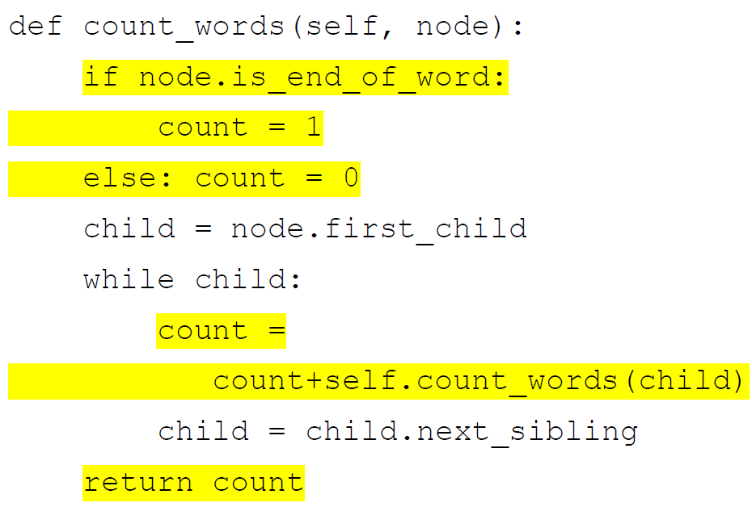

Q2 Given a Trie that stores multiple words, implement a function find_words_with_prefix() that returns all words that start with a given prefix. The function prototype is given as follows:

def find_words_with_prefix(self,node,prefix):

Example: for a trie consisting of words: ["cat", "cap", "bat", "ball", "car", "cart"], prefix = “ca”, the output will be ['cap', 'car', 'cart', 'cat']

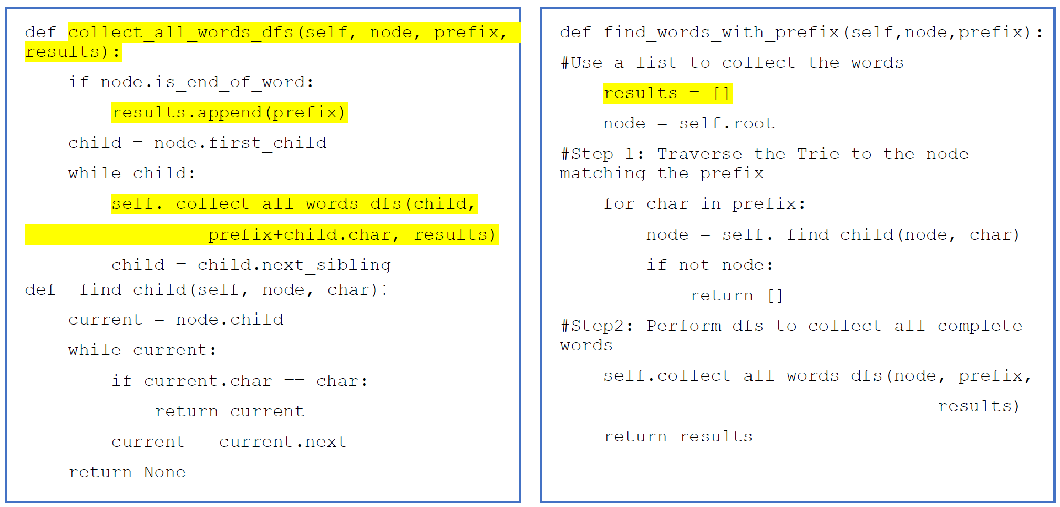

Q3 Given a Trie storing multiple words, write a function find_shortest_word_with_prefix() that returns the shortest word that starts with a given prefix. If no word starts with the prefix, return None.

def find_shortest_word_with_prefix(self,node,prefix):

Example: for a trie consisting of words: ["cat", "cap", "bat", "ball", "car", "cart"], prefix = “ca”, the output will be ['cap', 'car', 'cat'].

